
My Target: ____ /52 or _____%  

Name: ______
Total marks  52 | % | Weight  10%

Yr 7 Humanities & Social Sciences:

Task Four:
Ancient Egypt Topic Test

Reading – 5 minutes Working: 45 minutes

Instructions:
- Please attempt all questions.
- Look at the question and determine if the space provided is requiring a full sentence answer.

SECTION 1: Circle your answer (letter only) (10 marks)

Multiple Choice (Your Mark) = / 14

Read SOURCE ONE from the source page and it will help to answer some of the questions below…

- Which one of the following is the best statement of the subject of Passage 1 (as shown above)?

- Egypt the land of the Nile
- Soil fertility in Egypt
- The effects of the Nile River floods
- The ability of the Egyptians to cope with floods

- The Nile river flows…

- Southward
- Eastward
- Westford
- Northward

- According to the passage, the Nile forms a large delta which is good for…
- Tourism
- Growing crops
- Defence
- None of the above

- Which one of the following is the general direction of the flow of the Nile River?

- east to west
- north to south
- south to north
- west to east

- Papyrus was used

- to make paper
- as a food
- for clothing
- for decoration

- Irrigation was used extensively on the farms mainly because

- there was little or no rainfall
- the Nile water deposited rich silt
- wheat and corn grew only during floods
- irrigation was expensive

- Egypt is located within the continent of

- Europe
- South America
- Africa
- Asia

- The Nile River flows into the

- Mediterranean Sea
- Red Sea
- Black Sea
- Tasman Sea

- The ancient Egyptians were able to live in Egypt because they were able to farm around

- The Sahara Desert
- The Sinai Desert
- The Nile River
- The Amazon River

- Pharaoh was the Egyptian word for a

- noble
- queen
- king
- lord

- The tombs of the Pharaohs often took the form of

- crematoria
- catacombs
- cataracts
- pyramids

- Scribes were

- tools used for harvesting grain.
- men of Ancient Egypt who could write.
- Ancient Egyptian letters.
- a type of hieroglyphics.

- Pharaoh Hatshepsut was what?

- A child
- A woman
- A general
- A musician

- This group of people owned a lot of land and were very wealthy. They helped carry out the king’s orders and wished.

- Scribes
- The Army
- Governors
- Nobles and High Officials

Section Two – Short Answer

- Explain the location of Egypt. (2 marks)

__________________________________________________________________

__________________________________________________________________

__________________________________________________________________

__________________________________________________________________

__________________________________________________________________

- State two facts about the River Nile. (2 marks)

- _____________________________________________________________

__________________________________________________________________

- _____________________________________________________________

__________________________________________________________________

- Name the three seasons of The Farming Calendar.
(3 marks)
- ‘Season of Inundation’ - _____________________________

- ‘Season of Emergence’ - _______________________________

- ‘Season of Drought’ - ___________________________________

- Describe two reasons for why the River Nile was important to the Ancient Egyptians. (4 marks)

_________________________________________________________________

_________________________________________________________________

_________________________________________________________________

_________________________________________________________________

_________________________________________________________________

_________________________________________________________________

_________________________________________________________________

_________________________________________________________________

The following questions relate to the Climatic Data for Cairo – Egypt. SOURCE TWO

20a. What does the diagram show?. _____________________ (1)

20b. Which city had the most rainfall on average, for the year?____________ (1)

20c. What month did Aswan have the highest rainfall?___________________ (1)

20d. Which 2 cities had the highest average temperature for the year? (1)

___________________________________________________________________

21. Match the following words with their meanings. (4 marks)

Word Bank –

Pyramid Mummy Nile Pharaoh

Word | Meaning
 | The main river of Egypt.
 | The king or ruler of Ancient Egypt.
 | A preserved or embalmed body.
 | A large triangular tomb of stone blocks.

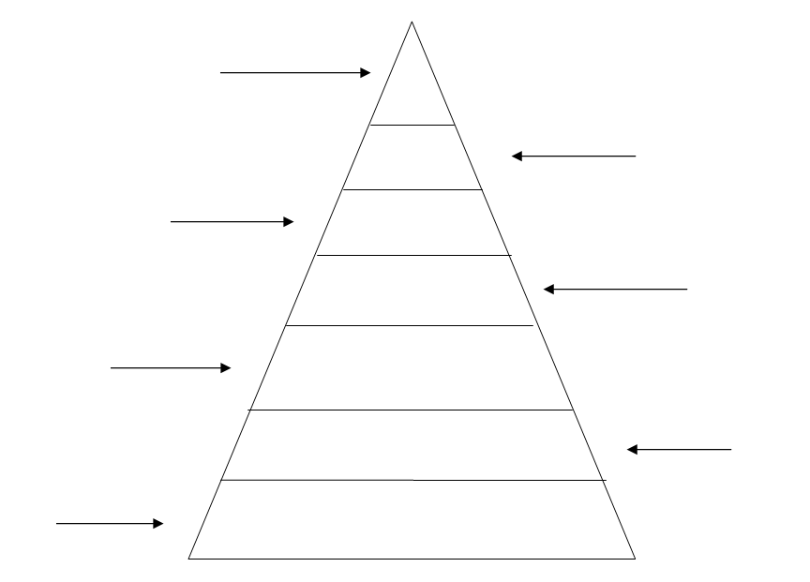
23. Fill in the social pyramid below. (7 marks)

Classes: Vizier, Nobles, Peasants, Slaves, Scribes, Priests, Pharaoh

24. Fill in the table below by matching the word bank words to the main duties carried out. (4 marks)

Word bank –
Vizier Scribes Priests High Officials
Name | Main Duty
 | These people speak to the gods on behalf of the pharaoh and the people.
 | These people work for the pharaoh. They own a lot of land and are very wealthy.
 | These people record everything that is important to the pharaoh and the running of the country.
 | This is the pharaoh’s right hand man. He carries orders of the pharaoh and performs special duties.

- Name three Egyptian Gods and state one quality about that god. (6 marks)
Name of God | Quality

- Outline two roles of the Pharaoh. (2 marks)

- ____________________________________________________________________________________________________________________________

- ____________________________________________________________________________________________________________________________
End of test paper
SOURCE PAGE

SOURCE ONE

Egypt is located in the north eastern part of Africa. The Mediterranean Sea lies north of it and the Red Sea lies to the east.
In ancient times Egypt was a long and narrow country. Egyptians could travel up and down the length of the country using the Nile River as a “highway”.
The Nile is the longest river in the world – approximately 6650kms long. The waters of the Nile flow northward from the highlands of central Africa to the Mediterranean Sea. At its Mediterranean end the Nile has formed a large delta. A delta is a fan shaped piece of land at the mouth of a river. The Nile Delta is made up of mud and sand that is carried down the river. The soil of the delta is good for growing crops.
Most of Egypt is a dry, desert land. Except for the fertile Nile Valley and Delta, there is little land that can be used for farming. The yearly average rainfall is less than 25cm. The summer temperature is over 38º C in the shade. In the winter the days are sunny and the temperature seldom falls below 4º C.

SOURCE TWO

